**DETECTION OF DYNAMIC FACE MASK USING MACHINE LEARNING**

kanisha .B   
Department of IT,  
Saveetha Engineering college,Chennai, Tamil Nadu [kanisha.vnb@gmail.com](mailto:kanisha.vnb@gmail.com)

G NaliniPriya  
Professor , Department of IT ,  
Saveetha Engineering college,Chennai, Tamil Nadu  
[dr.g.nalinipriya@gmail.com](mailto:dr.g.nalinipriya@gmail.com)

Monica J K   
Department of IT,  
Saveetha Engineering college,Chennai, Tamil Nadu [monicajk2007@gmail.com](mailto:monicajk2007@gmail.com)

Siva vadivu ragavi.v   
Department of IT,.  
Saveetha Engineering college,Chennai, Tamil Nadu [vsivavadivuragavi03@gmail.com](mailto:vsivavadivuragavi03@gmail.com)

*Abstract*—Omicron has impacted negatively on our everyday lives in a short amount of time. Nowadays wearing a face mask is mandatory to safeguard ourselves. With the use of the Face Mask Detection System, we can aid our society in preventing the spread of omicron. We used machine learning techniques such as TensorFlow, Keras, OpenCV, and Python to realise this concept in this paper. As a Monitor, it can keep track of multiple faces at once during a live stream. On different databases, it has a reliability of up to 90%. We can readily distinguish between persons wearing masks and those who are not, and the key benefit is that many faces may be recognised at the same time. It will be very useful in a crowd, and it can be improved by adding more features.

*Keywords: Face Mask Detection, Machine Learning, Keras, Open CV, Tensor flow, Surveillance.*

I.Introduction

Humans used to wear masks to protect themselves from covid 19 and even before that to protect themselves from dust. Masks can help prevent the Omicron virus, according to philanthropists and brilliant researchers. Omicron is the current virus that has caused many people's health to deteriorate in the last year. Corona virus has been declared a worldwide epidemic by Great Health Care Centers in recent years due to the virus's rapid spread. Detecting people with or without facemask in public places is becoming more difficult. The spotting of persons wearing and not wearing masks is part of the tracking procedure. A Face Mask Detection method has been developed based on the most recent information. The proposed concept has the potential to be related to surveillance, allowing humans to be monitored. For individuals who aren't wearing their masks, we've included a voice note, and we've enhanced the accuracy of detecting numerous faces at once.

II. Related works

We had gone through many papers that use face mask detection system and we have found certain paper related to our paper.

M. S. Ejaz et al [1], Principal Component Analysis (PCA) was used by the authors to identify faces with masks. It is necessary for user safety. This method is used to determine whether or not a person is wearing a mask on their face. It demonstrates that using a detection approach, the face mask detection system can help to reduce the spread of Omicron.

Bosheng Qin et al [2], the authors developed detection of face mask conditions, like how they are wearing the masks. It detects whether the persons mask is properly worn. The output will be wearing-masks, non-wearing mask, incorrectly wearing. This method achieved 85% in accuracy. Kaihan Lin et al [3], Using the Generalized Intersection over Union (GIoU) approach, the authors devised a method for identifying mask-wearing and mask-free faces. By identifying faces in the background, this approach helps to decrease background noise. GIoU method is used instead of bounding boxes as they add noise to the detection.

N. Ud Din et al [4], The authors discovered that data from images was processed for face mask detection. This is done by using spectrograms. The inputs are given for the purpose of detection. One of the components in the detection is the ResNet resource. Nicolae-Cătălin Ristea et al [5], The Face Mask Reconstruction method was proposed by the authors. The removal of a face mask from a face and the rebuilding of a face using the CelebA dataset are the two detection procedures used in this method.

S. Ghosh et al [6], According to this, the authors discovered that Convolutional Neural Networks are used to detect face masks (CNNs). It uses computer vision to aid in the detection of images with greater clarity. It uses computer vision to rebuild the images. M. Hashemi [7], For face mask detection, the authors presented a 3D feature tensor. The photos are used as input to the three-dimensional tensor, with each image having its own pixel. The 3D feature approach requires that all photos be of the same size. In 3D feature tensor detection, the size employed is critical.

C. Nwankpa et al [8], the authors used gradient-descent method for optimization of linear function which contains linear methods. The comparisons with other activation resources shows that the performance and reliability in deep learning is improved. D. Meena et al [9], According to this research, the authors proposed face detection method. It includes expression recognition, face tracking and position detection. Face will be identified from a picture. Faces change in size, shape, colour, and other characteristics, making it difficult to recognise them. It is useful for opaque image prevented by confronting the camera.

C. Kanan et al [10], proposed by the authors Modern computing image recognition technology will be used to perform grayscale recognition. This system only works with grayscale photos and does not expand the process. It's used to transform an image colour to a grayscale version. Its purpose is to avoid negative effects when employing robust computing approaches. The grayscale will simplify the algorithm and reduce the computational requirements. Instead of working with colour photos, extracting computational approaches will be used.

B. Suvarnamukhi et al [11], The authors devised a method for pre-processing data. It entails converting data from an unfamiliar format to a more user-friendly format. The transformed data format is the one that you want. Images, tables, videos, graphs, and other types of data are all acceptable. This discovers the relationship between several items, which will be utilised to create an organised data set.

F. Hohman et al [12], For the face mask detection process, the authors presented a Data Visualization approach. It's the process of employing knowledge representations and encodings to transform existing data into meaningful descriptions. The data visualisation technique will be based on the dataset's specific pattern.

M. Jiang et al [13], Face Mask Detection System was developed by the authors. The location of the faces is recognised in this method, as well as whether or not the face has a mask on it. This has something to do with the object detecting approach. Its purpose is to identify the classes of items, such as images. Face recognition is concerned with classifying various items. This system monitors autonomous driving, detection, and surveillance.

R. Yamashita et al [14], The authors discovered that in computer vision tasks, CNN is the most commonly used approach. This approach was utilised to distinguish between mask-wearing and non-mask-wearing faces. S. Ge et al [15], The authors found two face detection processes as a result of this research. 1) Masked and unmasked face datasets are both unavailable. 2) Image detection of facial expressions. Face synchronisation will be done using the Locally Linear Embedding technique.

III. System architecture

In proposed system,

At phase 1: Initially datasets have been loaded to recognize the faces. The datasets are then trained and tested for classification.

At phase 2: Face mask classifier is loaded from the disk. At first voice instruction will be given for proper guidance to wear a mask. Data analysis will take place in next step. Datasets will be analyzed for detection. From that dataset, faces with mask and without mask are identified. Face Mask Detection system is done in Live Stream to know the immediate result. Accuracy of the facemask will be detected. The final output is displayed as “Mask” or “No Mask” with Accuracy.

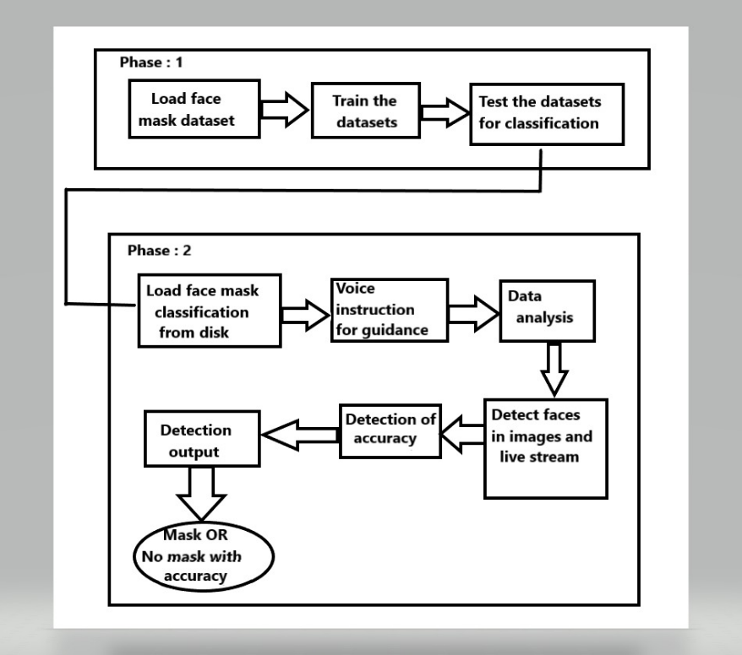

**Fig. 1.** Proposed system architecture

To detect a facemask on a human, the proposed system employs Machine Learning technologies such as Python, OpenCV, Keras, and TensorFlow. We will use the exact database, and the system will be instructed to predict the presence of the mask. We use a special model that checks for accuracy and can rate the people after training the datasets. In a live stream, the proposed system can detect multiple faces with or without masks. The proposed system improves the accuracy of the Masked and Non-Masked faces.

*Proposed algorithm*

The proposed system gives an edge over the existing system by detecting multiple faces at a time and can detect in live stream. Datasets are loaded to detect the face with mask and without mask. Figure2 explains proposed MKS Algorithm.

MKS ALGORITHM:

|  |
| --- |
| **Input**: Dataset  **Output**: Accuracy is detected  **Step 1**: Start  **Step 2**: Datasets are taken as input.  **Step 3**: Datasets are images with and without masks.  **Step 4**: Dataset will be loaded to recognize the faces.  **Step 5**: Face masks of the persons will be detected.  **Step 6**: The person will be instructed with a voice note.  **Step 7**: Face mask detection will be done by live video stream.  **Step 8:** Multiple faces can be detected at a time.  **Step 9:** The output is detected with accuracy.  **Step 10:** Stop |

**Fig. 2.** Proposed Algorithm for face mask detection

This algorithm shows that we can detect the faces by using the datasets as inputs. After the datasets are loaded, the process begins to detect the faces with mask or without mask. The output will be implemented by the Face Mask system and the live video streams.

IV. Implementation

The concept is implemented using OPEN CV, Keras, TensorFlow. They are trained by 3 ways:

1. Load datasets from the disc.

2. Recognize faces in the image.

3. Use a face mask detector to distinguish between faces with and without masks.

Let us consider an image as an input and that needed to be analysed with the help of face Mask detector model. Time and video stream class is required for loading which will make easier to work with the live stream.

*A.* ***OPEN CV:***

It is a library function which is capable of analysing the images and processing it. This means it is great at taking frames out of video or taking two frames from a camera and run algorithms to extract the information. With the help of this, individuals can process images and videos to find the objects, faces. Here this is used to classify the faces, object and the movement in the videos. By using the characteristics of Open CV, it will be helpful for us to change the colour and the size of an image.

*B.* ***KERAS:***

These are used for deep learning and it is mainly written for python language. Keras is Amazing, because it mainly focuses more on being user friendly for beginners, as well as for extensible, and modular as well. However, Keras not able to handle any of the low-level computations that you may want to do. It will do this through another library that is known as Backend. Users are able to use it through this module and we can also take the time to operate and use this library separately and independently.

*C****. TENSORFLOW:***

TensorFlow is just arrangement of arrays of numbers and it is mainly for doing graph-based works like bar chart. Machine Learning toolkits, but has the support of Machine Learning team staff composed of many of the leading professionals (Including one of Caffe's architects, builder of one of the fastest convolutional network frameworks).

It also has a dynamic visualization toolkit and a high-performance model server.

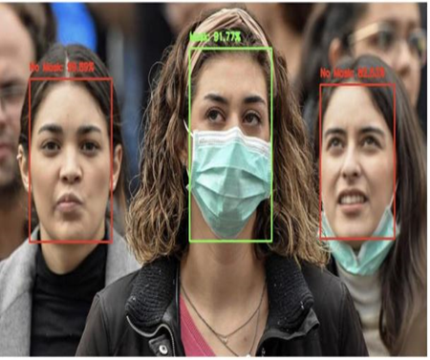

**Fig. 3.** Face Mask detection of Images

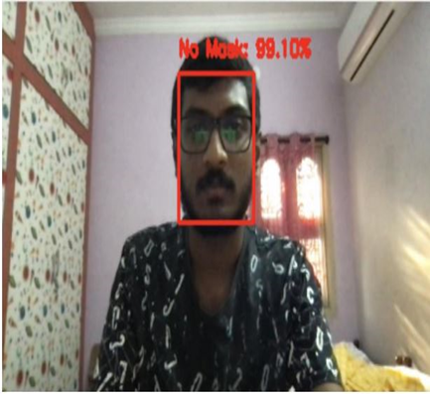

**Fig. 4.** Face detected without mask in live stream

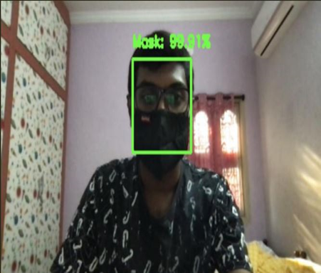

**Fig. 5.** Face detected with mask in live stream

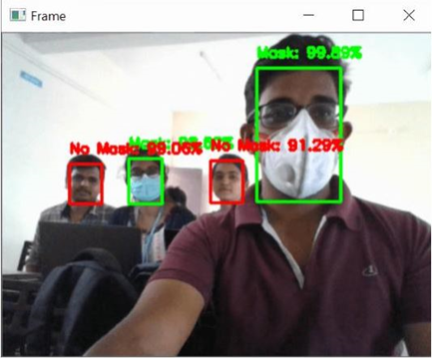

**Fig. 6.** Face Mask Detection with multiple faces

In figure3, Face Mask Detection used for detection in crowd, Here the red light indicates those persons without masks and the green colour indicates for those persons with mask**.** In figure4**,** here it is used for detection of a single

person, and the red light indicates the person is without mask.

Following that, it will provide a voice message instructing that user to put on a mask. Figure 5 shows a green light after the mask has been worn. Face Mask Detection is used in figure 6 to detect multiple people at once.

While detecting the output, a box will display over the person's face, indicating whether or not they are wearing a mask. It displays the output with mask wearing accuracy. When the person is without a mask, a red colour box will emerge with the accuracy "No mask: 99.01 %." When the user is wearing a mask, a green colour box will emerge with the accurate percentage "Mask: 99.91 %." Multiple faces can be detected in real time, and the output will be based on the person's condition. It displays the output for all of the individuals.

V.Comparison between proposed and existing system

In comparison of proposed model with other project model, we get that the proposed system gives an accuracy of 95% higher than other existing system and we have compared the no of sample, time taken and by inferring this we could able to see that number of samples that we collected is higher than the 3 existing system and the time taken in proposed system is also less when compared to three existing system which will be helpful in providing quick result. This comparison is useful to detect the accuracy of the existing system and proposed MKS system.

|  |  |  |  |  |
| --- | --- | --- | --- | --- |
| **SI.NO** | **SYSTEM** | **ACCURACY OF IMAGES** | **NOOF SAMPLES** | **TIME**  **TAKEN** |
| 1. | MIN system | 91.3% | WM=500  WOM=500 | 6m30s |
| 2. | ACS system | 88% | WM=700  WOM=700 | 4m20s |
| 3. | SVM system | 77% | WM=900  WOM=900 | 3m41s |
| 4. | Proposed  MKS system | 95% | WM=1500  WOM=1500 | 1m25s |

**Fig. 7.** Comparison of detection systems

*BAR CHART REPRESENTATION:*

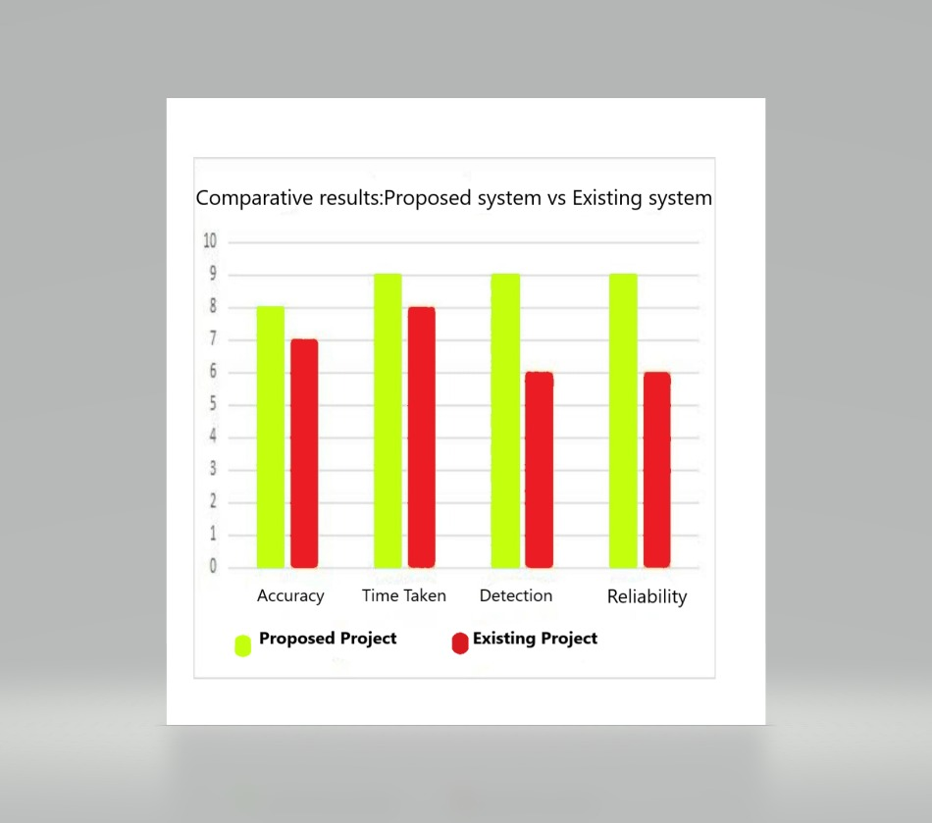

**Fig. 8.** Comparison Bar Chart

The above bar chart describes the relative survey of the proposed system with other face mask detection systems. On comparing this with other literature papers, we were able to infer that our paper is much better in terms of attributes such as accuracy, time taken, and reliability. The face mask detection system uses different algorithms, which include Tensor Flow, Open CV, and Keras. The proposed system's reliability is higher than the reliability of the existing system.

Overall, we can see a clear difference between the existing project and the proposed project. It also shows that it is more reliable, durable, and highly scalable.

VI. Result and discussion

The proposed system is a fully integrated Machine Learning based on face mask detection with the help of voice messaging. It permits the ability to detect the face masks of many people at a time. Those who do not properly wear their masks will be instructed.

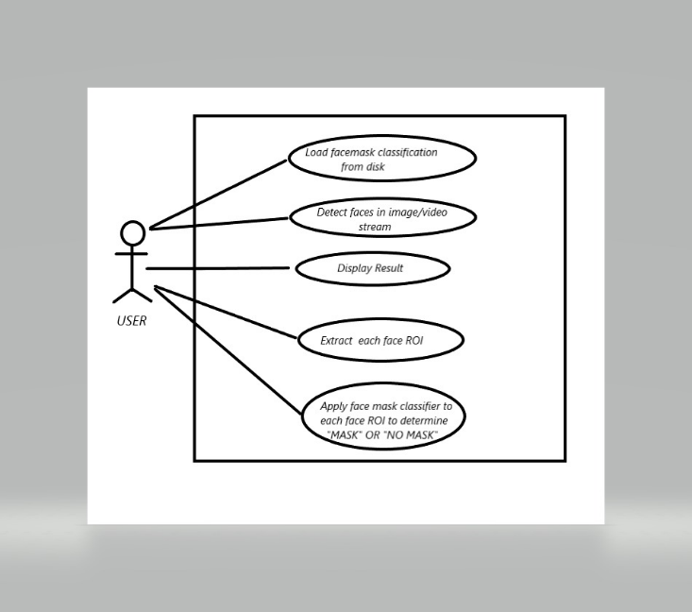

**Fig. 9.** Use case diagram for Face Mask Detection

The details of our system can be classified as:

* Our system interacts with the people.
* The goals of our system help our users and society as a whole.

Here, first we need to upload the datasets from the disc and then we need to find the faces in the live stream. For each ROI, we need to apply a face mask classifier to determine the faces with and without masks. Here, we need to load the face mask dataset to detect faces in images and live streams.

VII. Conclusion

At present, we are able to see that there are so many cases increasing day by day, especially in the Omicron virus. The government is taking so many measures to control both the viruses and to help this, we have developed this face mask detection which will help to identify those who have MASK and those who do not have MASK at a time (i.e.) Multiple faces can be detected at the same time, which is more useful for detecting people in a crowd. In this case, our proposed system will also play an important role in assisting those who do not have masks by providing instructions on how to properly wear their mask. This system can be easily used in public places such as streets, malls, examination centres, and it can also be used in smart city innovation, which will also be a boost for the development process in many countries. Further, we will be developing this project by adding GPS location. With this, we can easily detect the faces in crowd and identify the people with and without masks, and a message will be sent to those who are not wearing their masks.

References

[1] M. S. Ejaz, M. R. Islam, M. Sifatullah and A. Sarker, "Implementation of Principal Component Analysis on Masked and Non-masked Face Recognition", 2019 1st International Conference on Advances in Science Engineering and Robotics Technology (ICASERT), pp. 1-5, 2019.

[2] BOSHENG QIN and DONGXIAO LI, Identifying Facemask-wearing Condition Using Image Super-Resolution with Classification Network to Prevent COVID- 19, May 2020, [online] Available: <https://doi.org/10.21203/rs.3.rs-28668/v1>+].

[3] Kaihan Lin, Huimin Zhao, Jujian Lv(&)Jin Zhan, Xiaoyong Liu, Rongjun Chen, Canyao Li, Zhihui Huang et al., "Face Detection and Segmentation with Generalized Intersection over Union Based on Mask R- CNN", Advances in Brain Inspired Cognitive System, pp. 106-116, 2020.

[4] N. Ud Din, K. Javed, S. Bae and J. Yi, "A Novel GAN-Based Network for Unmasking of Masked Face", in IEEE Access, vol. 8, pp. 44276-44287, 2020.

[5] Nicolae-Cătălin Ristea and Radu Tudor Ionescu, Are you wearing a mask? Improving mask detection from speech using augmentation by cycle-consistent GANs.

[6] S. Ghosh, N. Das and M. Nasipuri, "Reshaping inputs for convolutional neural network: Some common and uncommon methods", Pattern Recognition, vol. 93, pp. 79-94, 2019.

[7] M. Hashemi, "Enlarging smaller images before inputting into convolutional neural network: zero-padding vs. interpolation", Journal of Big Data, vol. 6, no. 1, pp. 2019.

[8] C. Nwankpa, W. Ijomah, A. Gachagan and S. Marshall, "Activation Functions: Comparison Of Trends In Practice And Research For Deep Learning", 2020, [online] Available: <https://arxiv.org/abs/1811.03378.2020>.

[9] D. Meena and R. Sharan, "An approach to face detection and recognition", 2016 International Conference on Recent Advances and Innovations in Engineering (ICRAIE), pp. 1-6, 2016.

[10] C. Kanan and G. Cottrell, "Color-to-Grayscale: Does the Method Matter in Image Recognition?", PLoS ONE, vol. 7, no. 1, pp. e29740, 2012.

[11]  B. Suvarnamukhi and M. Seshashayee, "Big Data Concepts and Techniques in Data Processing", International Journal of Computer Sciences and Engineering, vol. 6, no. 10, pp. 712-714, 2018.

[12] F. Hohman, M. Kahng, R. Pienta and D. H. Chau, "Visual Analytics in Deep Learning: An Interrogative Survey for the Next Frontiers", IEEE Transactions on Visualization and Computer Graphics, vol. 25, no. 8, pp. 2674-2693, Aug. 2019.

[13] M. Jiang, X. Fan and H. Yan, "RetinaMask: A Face Mask detector", 2020, [online] Available: arXiv.org.

[14] R. Yamashita, M. Nishio, R. Do and K. Togashi, "Convolutional neural networks: an overview and application in radiology", Insights into Imaging, vol. 9, no. 4, pp. 611-629, 2018.

[15] S. Ge, J. Li, Q. Ye and Z. Luo, "Detecting Masked Faces in the Wild with LLE-CNNs", 2017 IEEE Conference on Computer Vision and Pattern Recognition (CVPR), pp. 426-434, 2017.